**How to fix DFSR replication:**

**Steps:**

1. Open computer management for all domain controllers
2. Stop DFSR service on all domain controllers

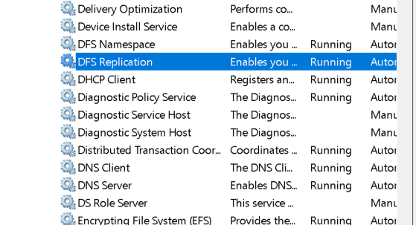

1. Open adsi edit

* Connect to Default Naming Context and DC1

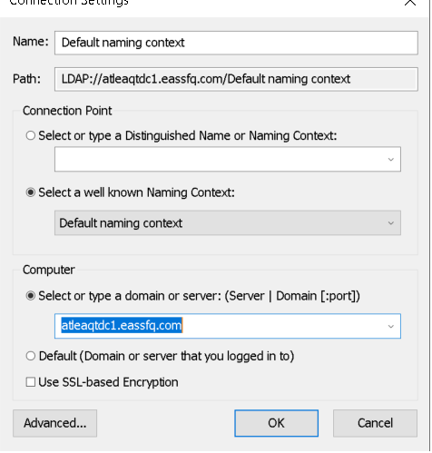

1. expand all folders down to

DC=eassfq,DC=com

-OU Domain Controllers

- CN=Atleatdc1

-CN=DFSR-localSettings

- CN=Domain System Volume

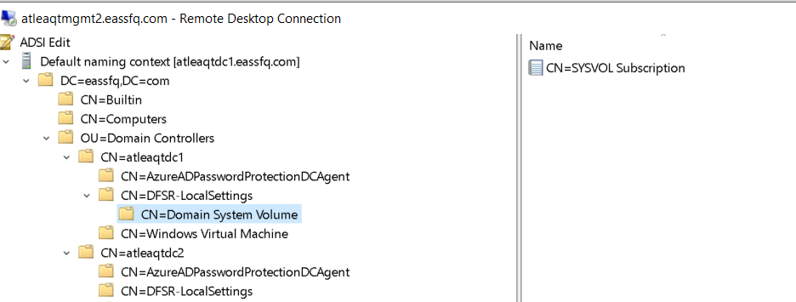

1. Double Click Cn=SYSVOL Subscription in the right window to edit properties

* ON DC1 you want to make

1. msDFSR-Enabled FALSE and

2. msDFSR-Options to 1 (This means Authoritative)

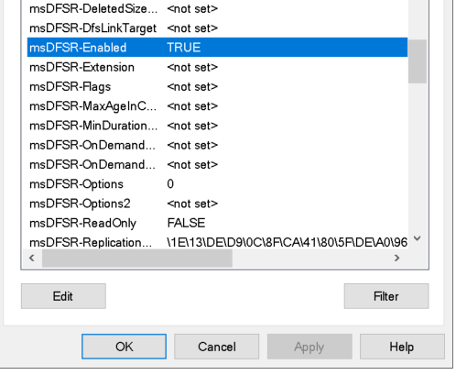

* On all other DCs ONLY set:

1. msDFSR-Enabled FALSE

1. Go to Powershell on DC1

* repadmin /syncall "NAME OF DC1" /APed

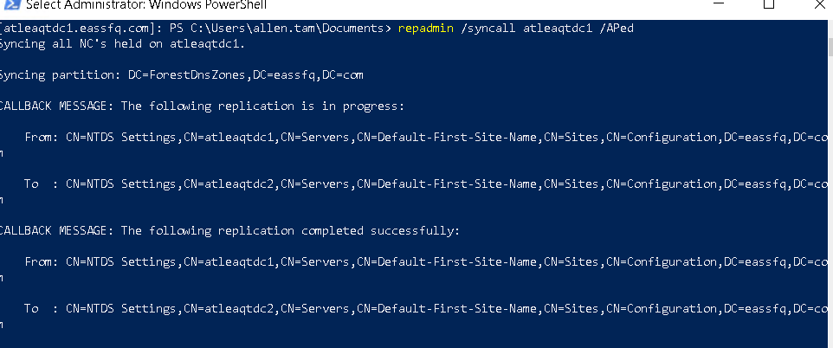

1. Go to dc1 computer management start DFSR service
2. Go to adsiedit and change back to enable Leave the 1 under options:
3. Go to back to powershell on DC1 Run:

* dfsrdiag pollad
* repadmin /syncall "NAME OF DC1" /APed

1. Go to Computer Management on DC2 Start DFSR service
2. Then Go to back to adsiedit, In DC2 properties, change msDFSR-Enabled back to true
3. Go to Powershell on DC2 and Run:

* drsrdiag pollad
* repadmin /syncall "NAME OF DC1" /APed

**Note: Repeat 10-12 for all other DCs in the Domain/Forest**

1. You're now done. Wait about 15 minutes then check Logs on the Domain Controllers to make sure all is syncing.